Heartland Global Health 2021 Conference Speakers
Dr. Oswaldo (Ozzie) Grenardo  SVP & Chief Diversity & Inclusion Officer Vaccine Equity Taskforce  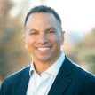 | Oswaldo (Ozzie) A. Grenardo MD, MBA, MSHA is a Colorado native. After graduating from Stanford University with a degree in human biology, he moved back to Denver to work in health care administration, earning a combined Master of Science in Health Administration and Master of Business Administration from the University of Colorado. He earned his medical degree from the University of Colorado and completed his residency training in family medicine through the University of Colorado at Rose Medical Center.Dr. Grenardo has been employed as a Centura physician since 2010 and is currently the Senior Vice President and Chief Diversity and Inclusion Officer. He was chosen for the Centura Health Physician Group Board of Directors in 2012, and served as the Vice Chair, and the Chair for the Board's Quality Committee. Dr. Grenardo is also on the clinical staff at Parker Adventist Hospital. For several years, he did rural outreach work in southeast Colorado and was the Assistant Dean of Admissions at the University of Colorado School of Medicine.His medical interests include health disparities and diversity issues. Dr. Grenardo was one of six US Pisacano Scholars selected in 2005 for his demonstrated leadership in medicine. In addition, he was an Adler Scholar, and recipient of the Virginia Schuman Scholarship, the Diversity Scholarship at the University of Colorado Medical School and was the Dean's Diversity Scholar while at the University of Colorado School of Medicine. Dr. Grenardo has a college-aged daughter and large blended family whom he loves dearly. He enjoys playing sports and is a fervent fan of the Denver Broncos and Denver Nuggets. Dr. Grenardo was a scholarship football player at Stanford for four years.
Dr Joe Smyser CEO The Public Good Projects  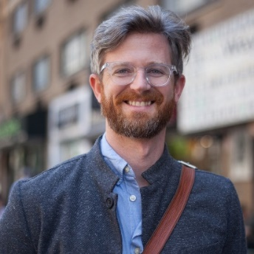 | Talk title: A community-centered approach to building vaccine confidence  Dr. Joe Smyser is the CEO of The Public Good Projects (PGP), a public health nonprofit that specializes in large-scale media monitoring programs, social and behavior change interventions, and cross-sector initiatives. Dr. Smyser has designed some of the United States' most influential and impactful health campaigns to date in partnership with the CDC, FDA, Kaiser Permanente, Rockefeller, and Humana. Dr. Smyser holds a PhD and master’s in public health and did his postdoctoral training at the CDC.PGP has successfully led one of the nation’s largest vaccine hesitancy programs for people of color (Black, Latinx, and Asian-Pacific Islander), Stop Flu, for the past three years. Additionally, in 2019 PGP developed the nation's largest vaccine communications monitoring program, Project VCTR, which is used by over 500 health organizations in the US. To expand on the proven efficacy of Project VCTR globally, PGP partnered with UNICEF to create the Vaccine Demand Observatory to track and respond to vaccine misinformation worldwide. In 2020 Dr. Smyser and PGP created Stronger, a national advocacy campaign, which works to stop the spread of misinformation by advocating for facts, science, and vaccines. Using multimedia campaigns, Stronger reaches millions of people each month through multiple channels, platforms and mediums.
Jacquie Easley McGhee  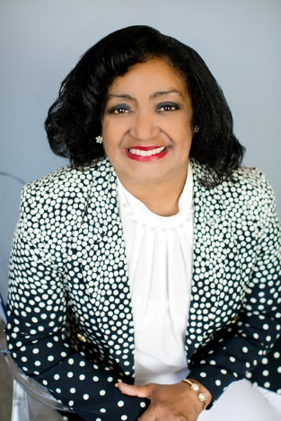 | Jacquie is Director, Health Equity, Community & Diversity Services for MercyOne Des Moines Medical Center. Her area of responsibilities include language access services and health equity initiatives for the organization. Jacquie holds a Bachelor of Arts degree from Carleton College in Northfield, Minnesota and a certification in Human Resource Law from the Society of Human Resources. Jacquie has been Chair of the Greater Des Moines partnership Diversity Council and Central Iowa Regional Workforce Investment Board, which oversees the planning and programming for workforce development for seven central Iowa counties. Currently Jacquie chairs the Directors Council/One Economy health strategic team and is the Iowa Nebraska NAACP Conference of Branches health chair. Elected in 1990, Jacquie was the first African American female to serve on the Des Moines School Board, the largest school district in Iowa. She served two terms, held the office of President, and was unanimously appointed by the School Board in 2000 to fill a vacancy. Jacquie was a primary finalist in the 2019 Des Moines City Council at large seat election. Among her honors and awards include the following: Inductee, Iowa Women’s Hall of Fame, Inductee, Iowa African American Hall of Fame, Des Moines Human Rights Commission Mary Louise Smith Diversity and Inclusion Award, Metro Women’s Association Woman of the Year, Business Record Woman of Influence, Dollars and Sense Magazine Outstanding Business and Professional Award, Iowa Jaycees’ Outstanding Young Iowan,YWCA Woman of Achievement, Outstanding Service to Youth by Zeta Phi Beta Sorority, Judge Luther Glanton Award for Outstanding Public Service, Outstanding Community member Junior League of Greater Des Moines,Des Moines University Community Diversity Champion US Bank Board of Directors member.
Julie Tyler N.P  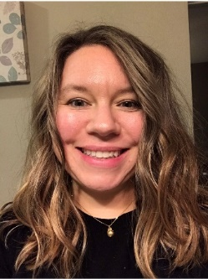 | After becoming a nurse in June of 2014, Julie worked as a med-surg/telemetry nurse and then  became a critical care nurse in May of 2018 at a level 1 trauma hospital. Over the years she has  gained a vast knowledge of various types of critical care patients. She is a team member for the  rapid response and code team, precept new nurses in the ICU, and teach Advanced Cardiac Life  Support (ACLS). As NYC continued to explode with COVID cases and the crisis grew, she was one of the first deployed teams of nurses to arrive at New York Presbyterian hospital in lower  Manhattan in 2020. During the COVID crisis of NYC. She has worked mostly in the ER and on one of makeshift critical care units throughout the hospital. After her time in NYC, she continued to work in a critical care setting primarily with COVID patients in various cities throughout the United States. Currently, she works as an ICU nurse at Altru Hospital in Grand Forks, ND.
Marti Doyle PhD, MSW  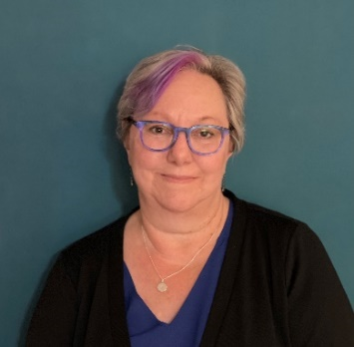 | Marti Doyle is a social science and bioethics professor at Mercy College of Health Sciences. Marti believes that introducing future health care practitioners to the social determinants of health and helping her students develop an ethical foundation for their personal and professional lives is an important part of her life’s legacy. After taking a 21-year break to raise her two children, Marti returned to higher education in her forties, earning three degrees in eight years. She holds a doctorate in Human Services from Capella University, a Masters of Social Work from the University of Iowa, a bachelors in Human Services from Grand View University, and a graduate certificate in Health Care Ethics from Creighton University.

